# Parameterized Pipelines

Giving provision to user to add values for different parameters in UI before starting build. This is very popular in most of the projects. Giving user control to set value for params and trigger the build.

## Boolean Param

Provides the checkbox in UI

pipeline{

    agent any

    parameters{

        // variable names and value are preferred as camel case in jenkins

        //define a boolean param

        booleanParam(defaultValue: false,

                    description: "Enable service ?",

                    name : "myBoolean")

    }

    stages{

        stage("Demo"){

            steps{

                // access the param value using string interpolation

                // syntax as mentioned below

                echo "Bolean param is set to : ${params.myBoolean}"

            }

        }

    }

}

It gives option to build with parameters and give option to change the value.

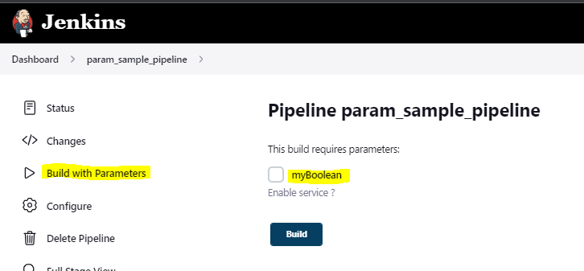

Configuring parameters is available in UI as well on pipeline settings, but **configuring it in code is mostly preferred in industry**. Below mentioned is not preferred.

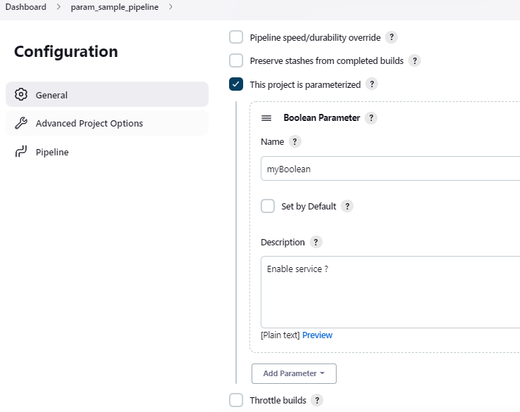

# String Param

pipeline{

    agent any

    parameters{

        string(defaultValue: "TEST",

                    description: "Which environment to deploy in ?",

                    name : "deployEnv")

    }

    stages{

        stage("Demo"){

            steps{

                echo "Deployment environment set to : ${params.deployEnv}"

            }

        }

    }

}

Which gives option to enter input text

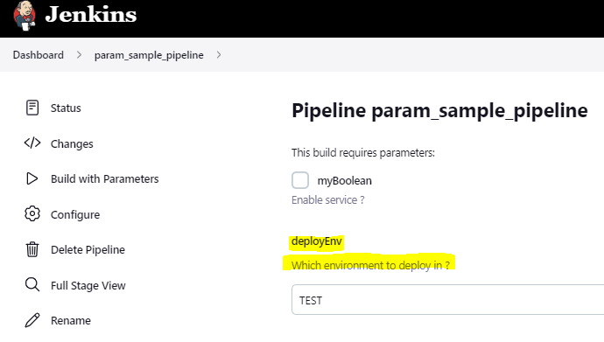

## Choice param

Give drop down list to choose options.

pipeline{

    agent any

    parameters{

        choice(choices: ["TEST","DEV","QA","PRE-PROD","PROD"],

                    description: "Which environment to deploy in ?",

                    name : "deployEnvChoice")

    }

    stages{

        stage("Demo"){

            steps{

                echo "Deployment environment set to : ${params.deployEnvChoice}"

            }

        }

    }

}

User gets dropdown in UI

